Ex no:5a Installation of KVM and creation of Virtual instances
Date:

Aim:
To install a KVM and creation of virtual instance for setting up a virtualized environment on linux system.
What is KVM?
KVM (Kernel-based Virtual Machine) is an open-source virtualization technology built into the Linux kernel. It turns Linux into a type-1 hypervisor that allows you to run multiple virtual machines (VMs) on a physical host.
Each VM has its own virtual hardware (CPU, RAM, disk, etc.), and runs its own full-fledged operating system.
Benefits of KVM
Feature | Benefit
Open Source | Free and supported by the Linux community.
Performance | Near-native performance using hardware virtualization (Intel VT or AMD-V).
Security | Isolation between VMs using SELinux and AppArmor.
Scalability | Can handle many VMs on a single host (scales well vertically).
Flexibility | Supports many OSes (Linux, Windows, BSD, etc.).
Integration | Works with tools like libvirt, virt-manager, OpenStack, etc.
Live Migration | Supports live VM migration between hosts.
Procedure:
Virtualization Technology
- Check Hardware Virtualization Support.
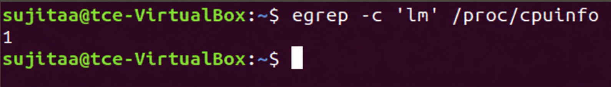
Output ≥ 1 indicates support. If 0, CPU doesn't support hardware virtualization.
- Run uname -a , which shows kernel name, hostname, kernel version, build date, architecture, and OS type in one line.
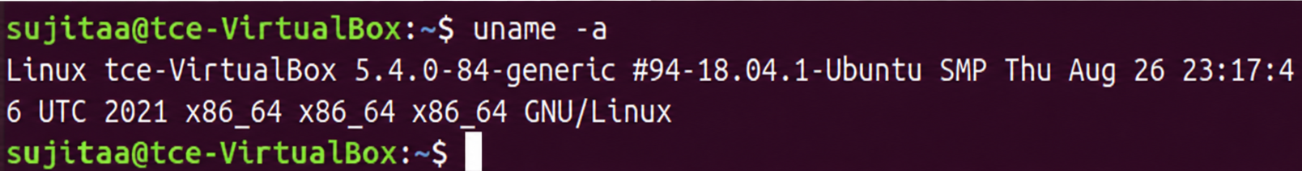
- To list the KVM kernel module files present in your kernel, run:
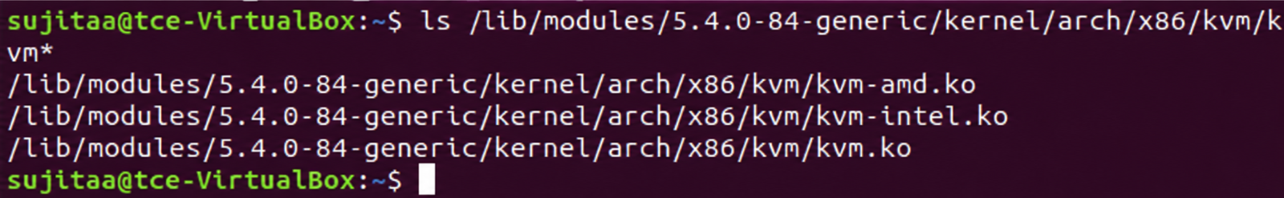

KVM Installation
- Install required packages :qemu-kvm, libvirt-bin, bridge-utils, virt-manager and qemu-system.
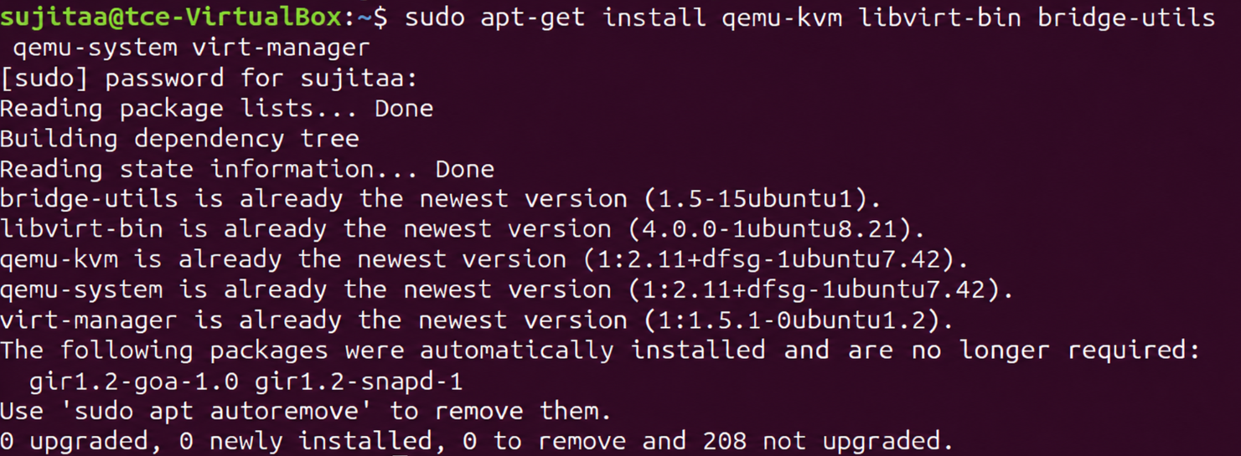
- Configure the libvirt daemon configuration file for remote access & socket permissions in KVM/libvirt
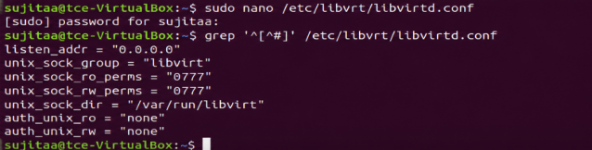
After configuring it, restart libvirtddervice.
- Run virsh list - Displays no of Virtual machine running.
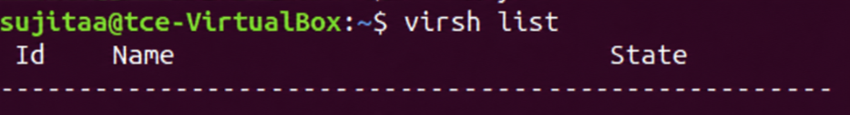
- Connecting to Virtualization interactive terminal.
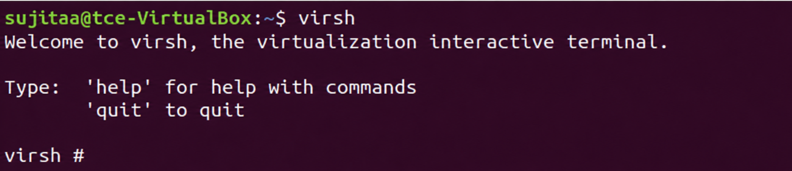
- Getting Version of libvirt& QEMU.
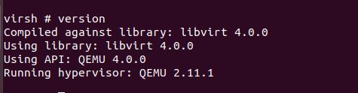
- Getting Node information
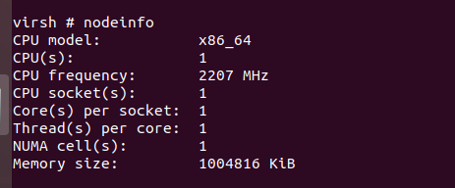
Importing existing VM
- Go to virtual machine manager (virt-manager) in your linux system. Then, right click QEMU/KVM and select New to create new VM.
- Select import existing disk image and click forward.

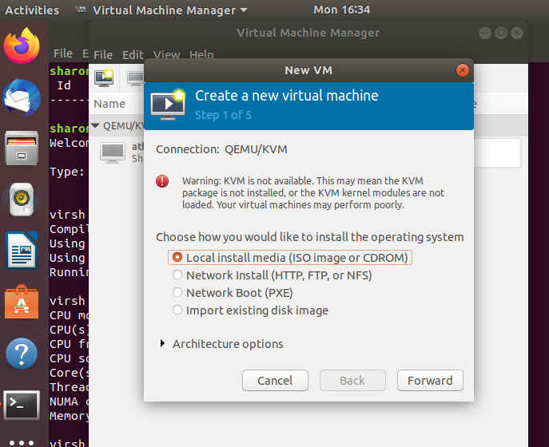

- Download cirros disk image from the link: https://download.cirros-cloud.net/0.5.1/
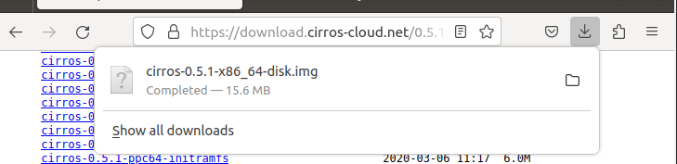

4.Give the path of downloaded cirros disk image and click forward.
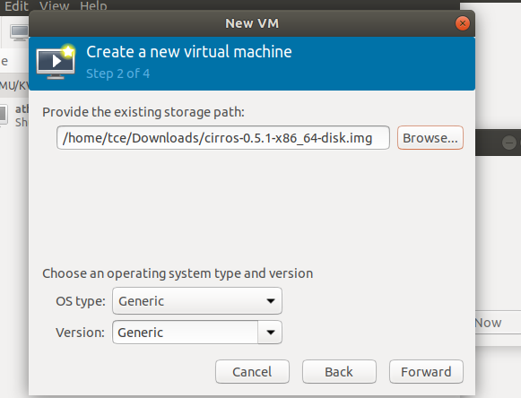

5. Choose memory and CPU settings and click forward.
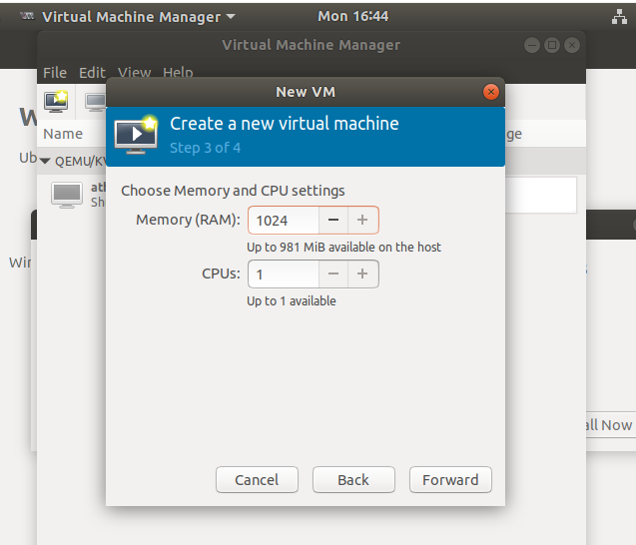

6.Name your VM and click Finish.
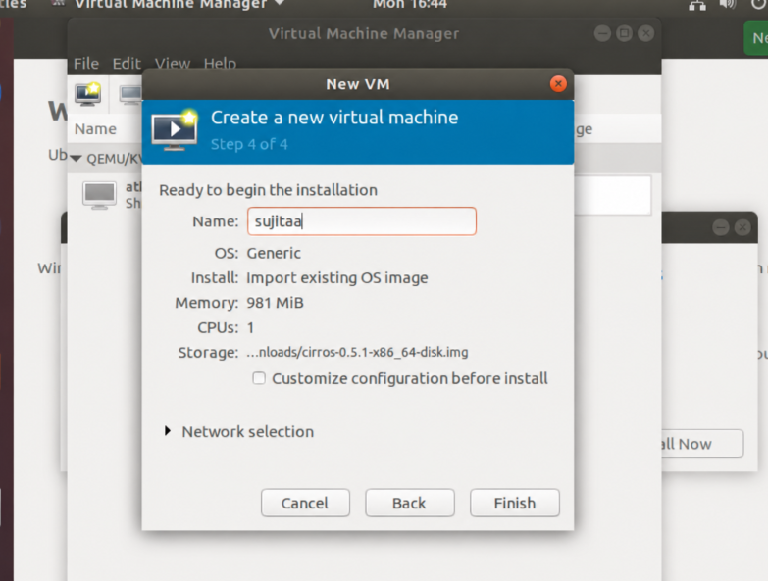

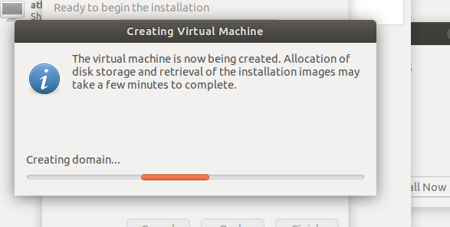

7.The VM is booted successfully and the login was also successful.
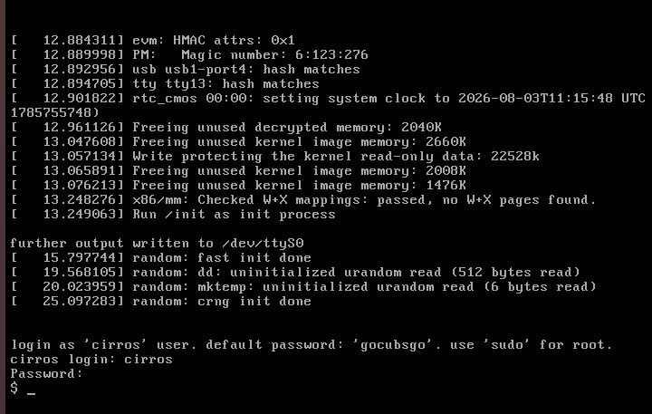

Result:
Thus, the KVM was successfully installed on the Linux system, and virtual instances were created and configured using Virt-Manager, demonstrating the setup of a virtualized environment.

